Topic: My video reflection

Directions:

Follow the steps below to create your digital reflective teaching video (reflection / comments)

The instructions will be based on using the iMovie video editing program on Macs.

Getting started

- Open “iMovie” from either the Dock or the “Applications” folder, or type “iMovie” in Spotlight Search /box.
Download your teaching video
- In Blackboard, navigate to the “Unit 3” à “Assignment Dropbox” à “5-Min Teaching Video Download Link” folder.
- To download your video, click on the link to your video in Google Drive.
- Sign in with your g.syr.edu account
  - Use your SU email address, but instead of @syr.edu, use @g.syr.edu
    - For example, jsmith@g.syr.edu
  - On the next screen, enter your SU username and password
- Download the file to someplace you can find it (preferably the Desktop)

Import your teaching video to iMovie

- Under the “Projects” area, click “Create New”, then click “Movie”
- Click on File => Import Media
- Click on Desktop => find your teaching video sample => click Import Selected

Review your videotaped teaching sample

- Click on the Play button (arrow pointing towards the right) under the video to view it in its entirety.
Video Editing: Inserting your reflections / comments

Your mission is to browse through your 5 min. teaching sample and insert “captions” (your comments and reflections from your HW assignment) into your microteaching video sample.
Let’s get started!

- Left-click and highlight the entire uploaded video until you see a yellow border around it.
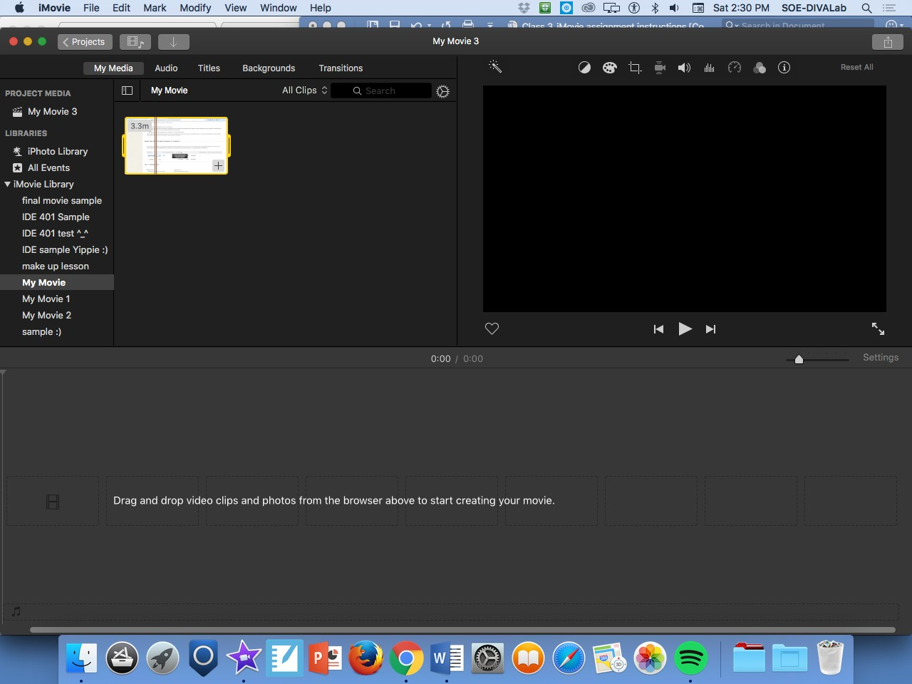

- Click on the yellow highlighted teaching sample and drag the snippet into the box below labeled: Drag and drop video clips and photos from the browser above to start creating your movie.
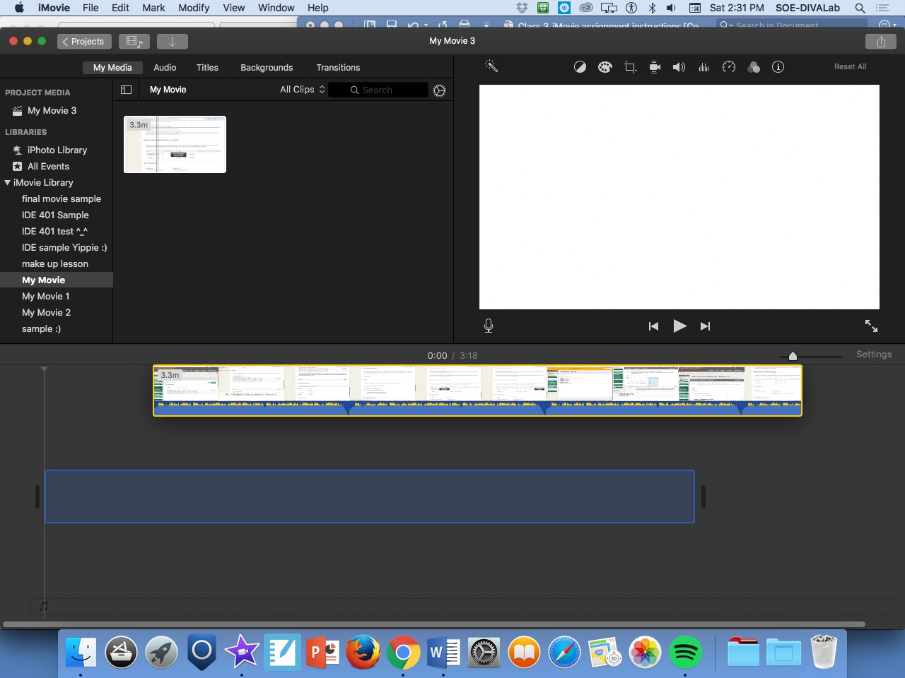

Video Editing: adding captions (your reflections)

- Find the following documents:
  - In Blackboard Dropbox Assignments => Unit 3 => Video Analysis
  - Video Break Down Sheet
  - Completed Technology Integration Observation Instrument
- Insert the title (T) page “Standard Lower Third” at a segment of the video you reflected on.
- Insert short/succinct one sentence reflection(s) that highlight your strengths or challenges
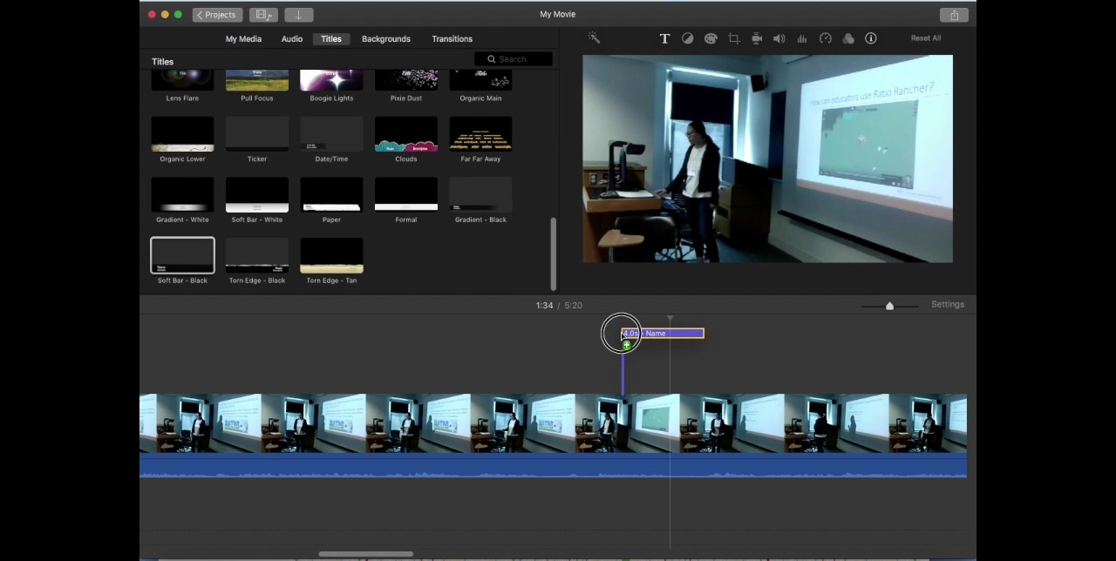

- You can adjust where and how long your captions will show by clicking and dragging the blue text box over your desired video segment highlights
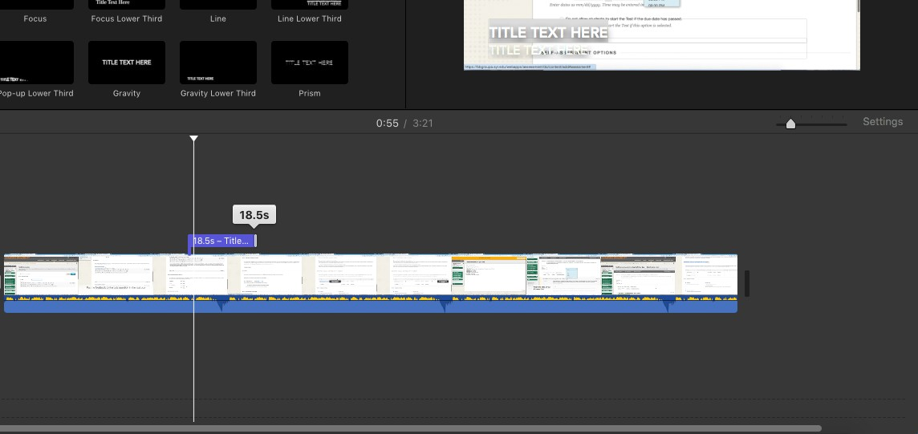

Video Editing: trim the video

- Watch the video from beginning, find out where the teaching start.
- Use Add Marker function to mark the start point of the first teaching sample
- Use Command-B (or right-click, Split Clip) to split the clip at your marker
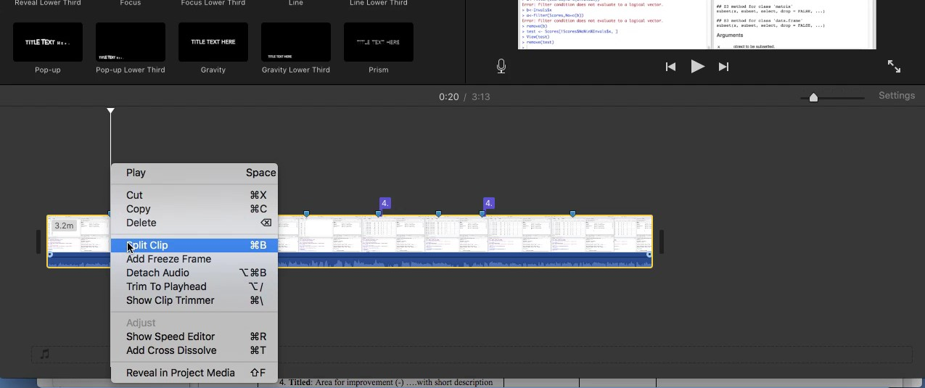

- Click on any split clips that are not part of your teaching. Use the “Delete” key to delete these clips so that you are left with only your teaching.
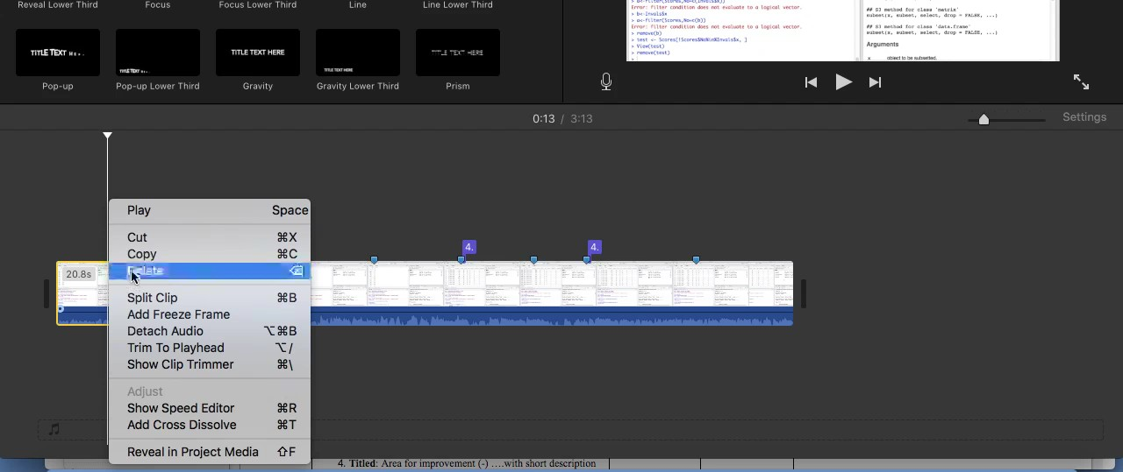

Video Editing: add “Introduction” slide

- Choose a Background for your title screen, click on the “Background” button on the top of the screen => select a background (anything you want)
- Once you’ve selected a background you like, click and drag the background to the far left of your video project.
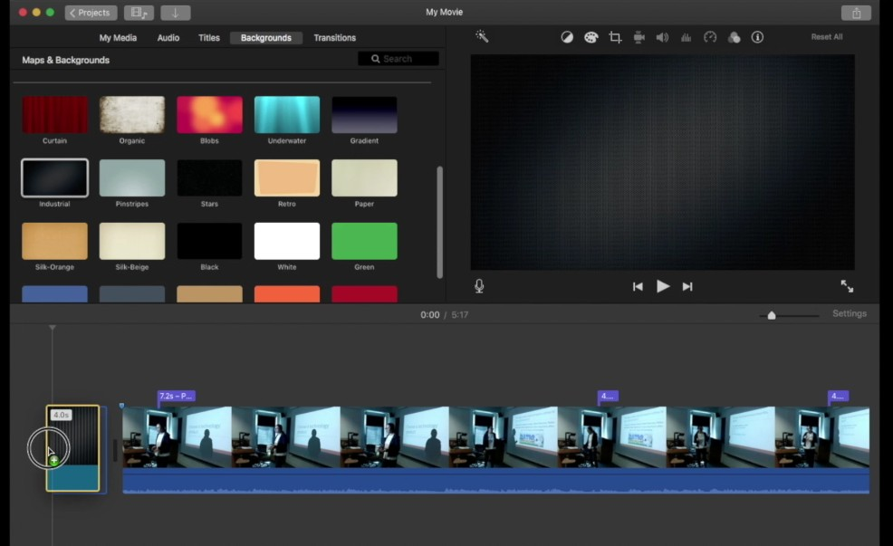

- To add a title screen, click on the “Title” button on the top of the screen => select a title screen (anything you want)
- Once you’ve selected a title screen that you like, click and drag the title screen to the far left of your video project, make sure the time duration of the title screen and the background are same.
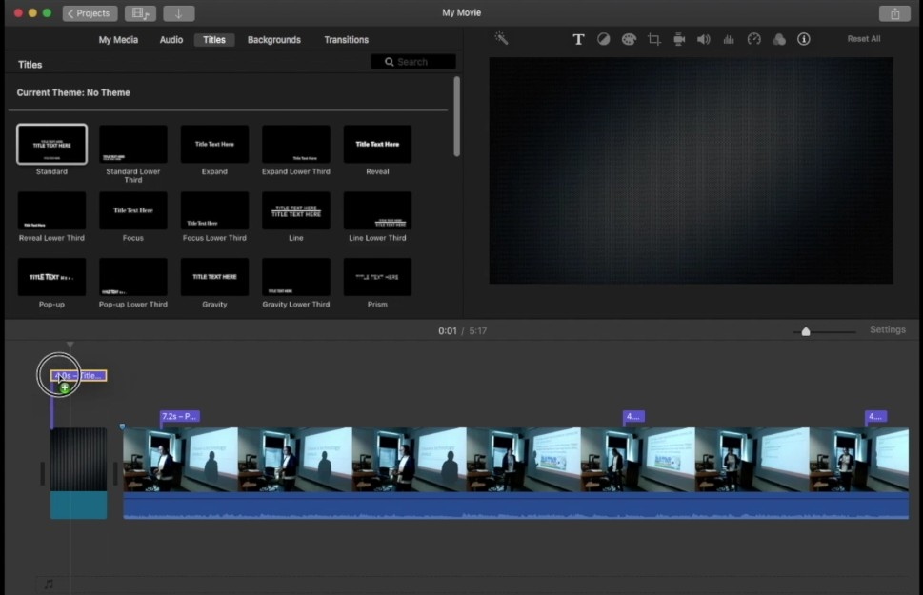

- At the end of the last video snippet, add a Title slide labeled: Lessons Learned
- Add additional Title slides to explain what you learned
  - You must list at least (2) examples of how you will improve integrating technology into your teaching.
  - You must list at least (2) examples of how you will improve your teaching pedagogy
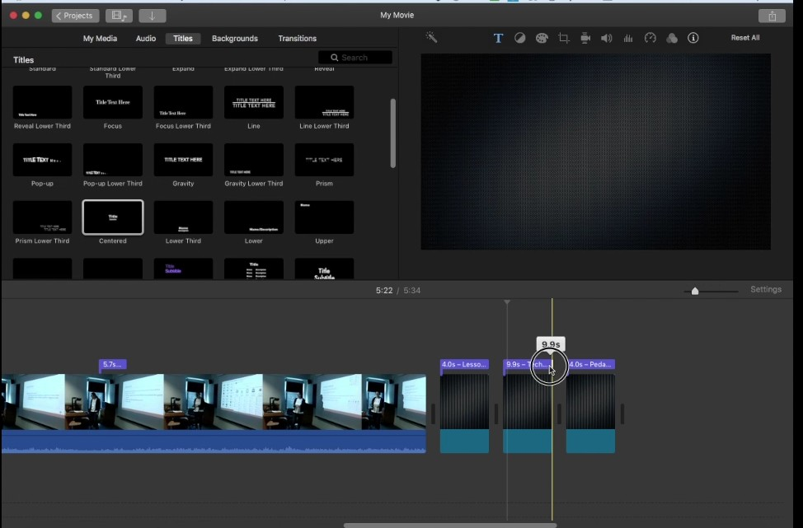

Video Editing: adding transitions

- Select a transition
- Click and drag selected transition into a “split”
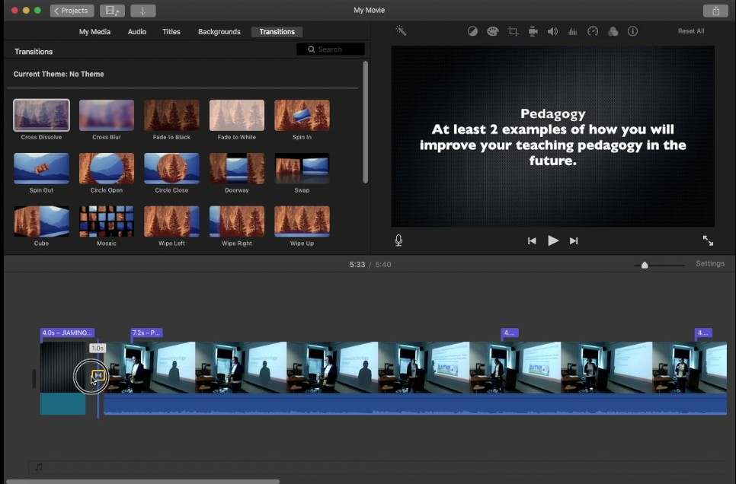

- Add a transition before the “Lesson Learned” slide
How to publish your video:

- Click on “File”, then “Share”, then “File”
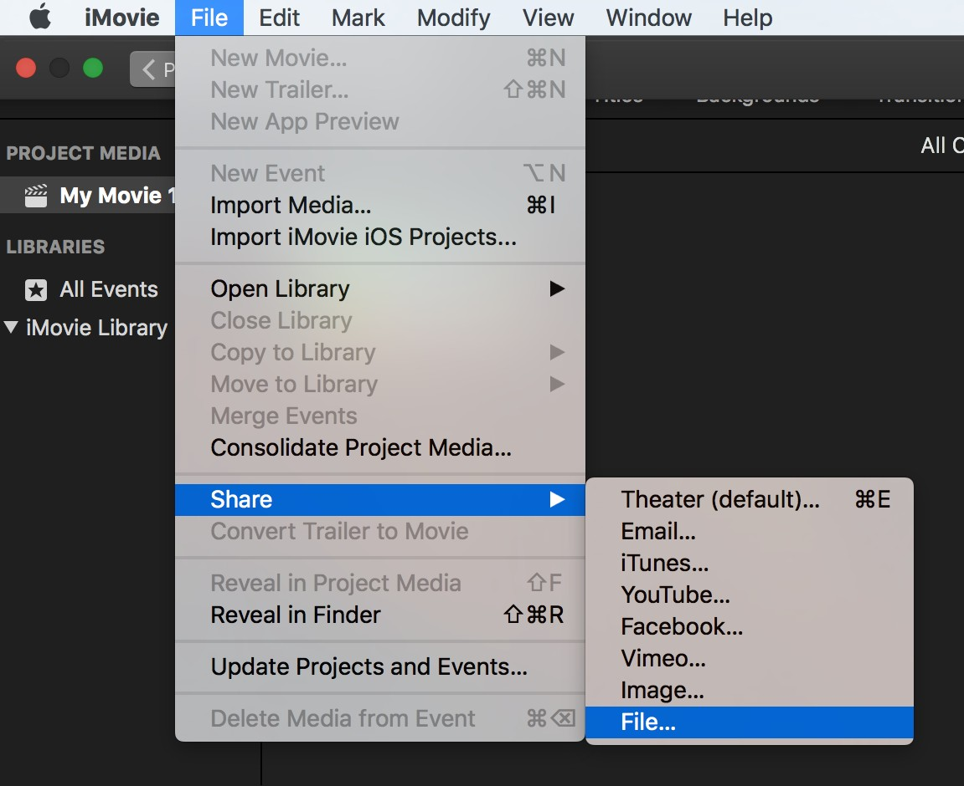

- Give your movie a Name and a Description.
  - Choose the lowest resolution and low quality. (This can save your time for waiting)
- Then, click “Next”
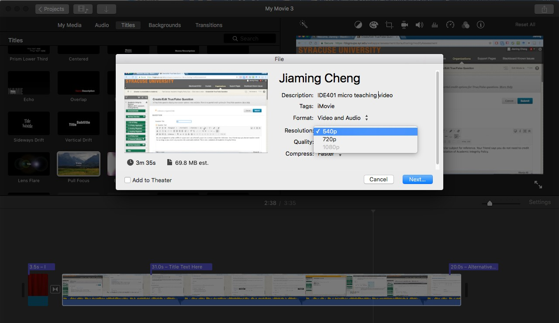

- Under where to save, select: Desktop
- Click Save
- After a few minutes, your exported video will appear on the Desktop

Submit your video to Blackboard:

- Upload your video to Google Drive, and paste the shareable link in the Unit 3 Assignment Dropbox -> The Reflection Teaching Sample: iMovie Tutorials and Submission Link

